**Fishery Manuscript No. 17-10**

**Escapement Goal Review of Copper and Bering Rivers, and Prince William Sound Pacific Salmon Stocks, 2020**

**by**

**Philip J. Joy**

**Stormy B. Haught Richard E. Brenner Jack W. Erickson James W. Savereide and**

**Timothy R. McKinley**

**XXXX 2020**

**Alaska Department of Fish and Game Divisions of Sport Fish and Commercial Fisheries**

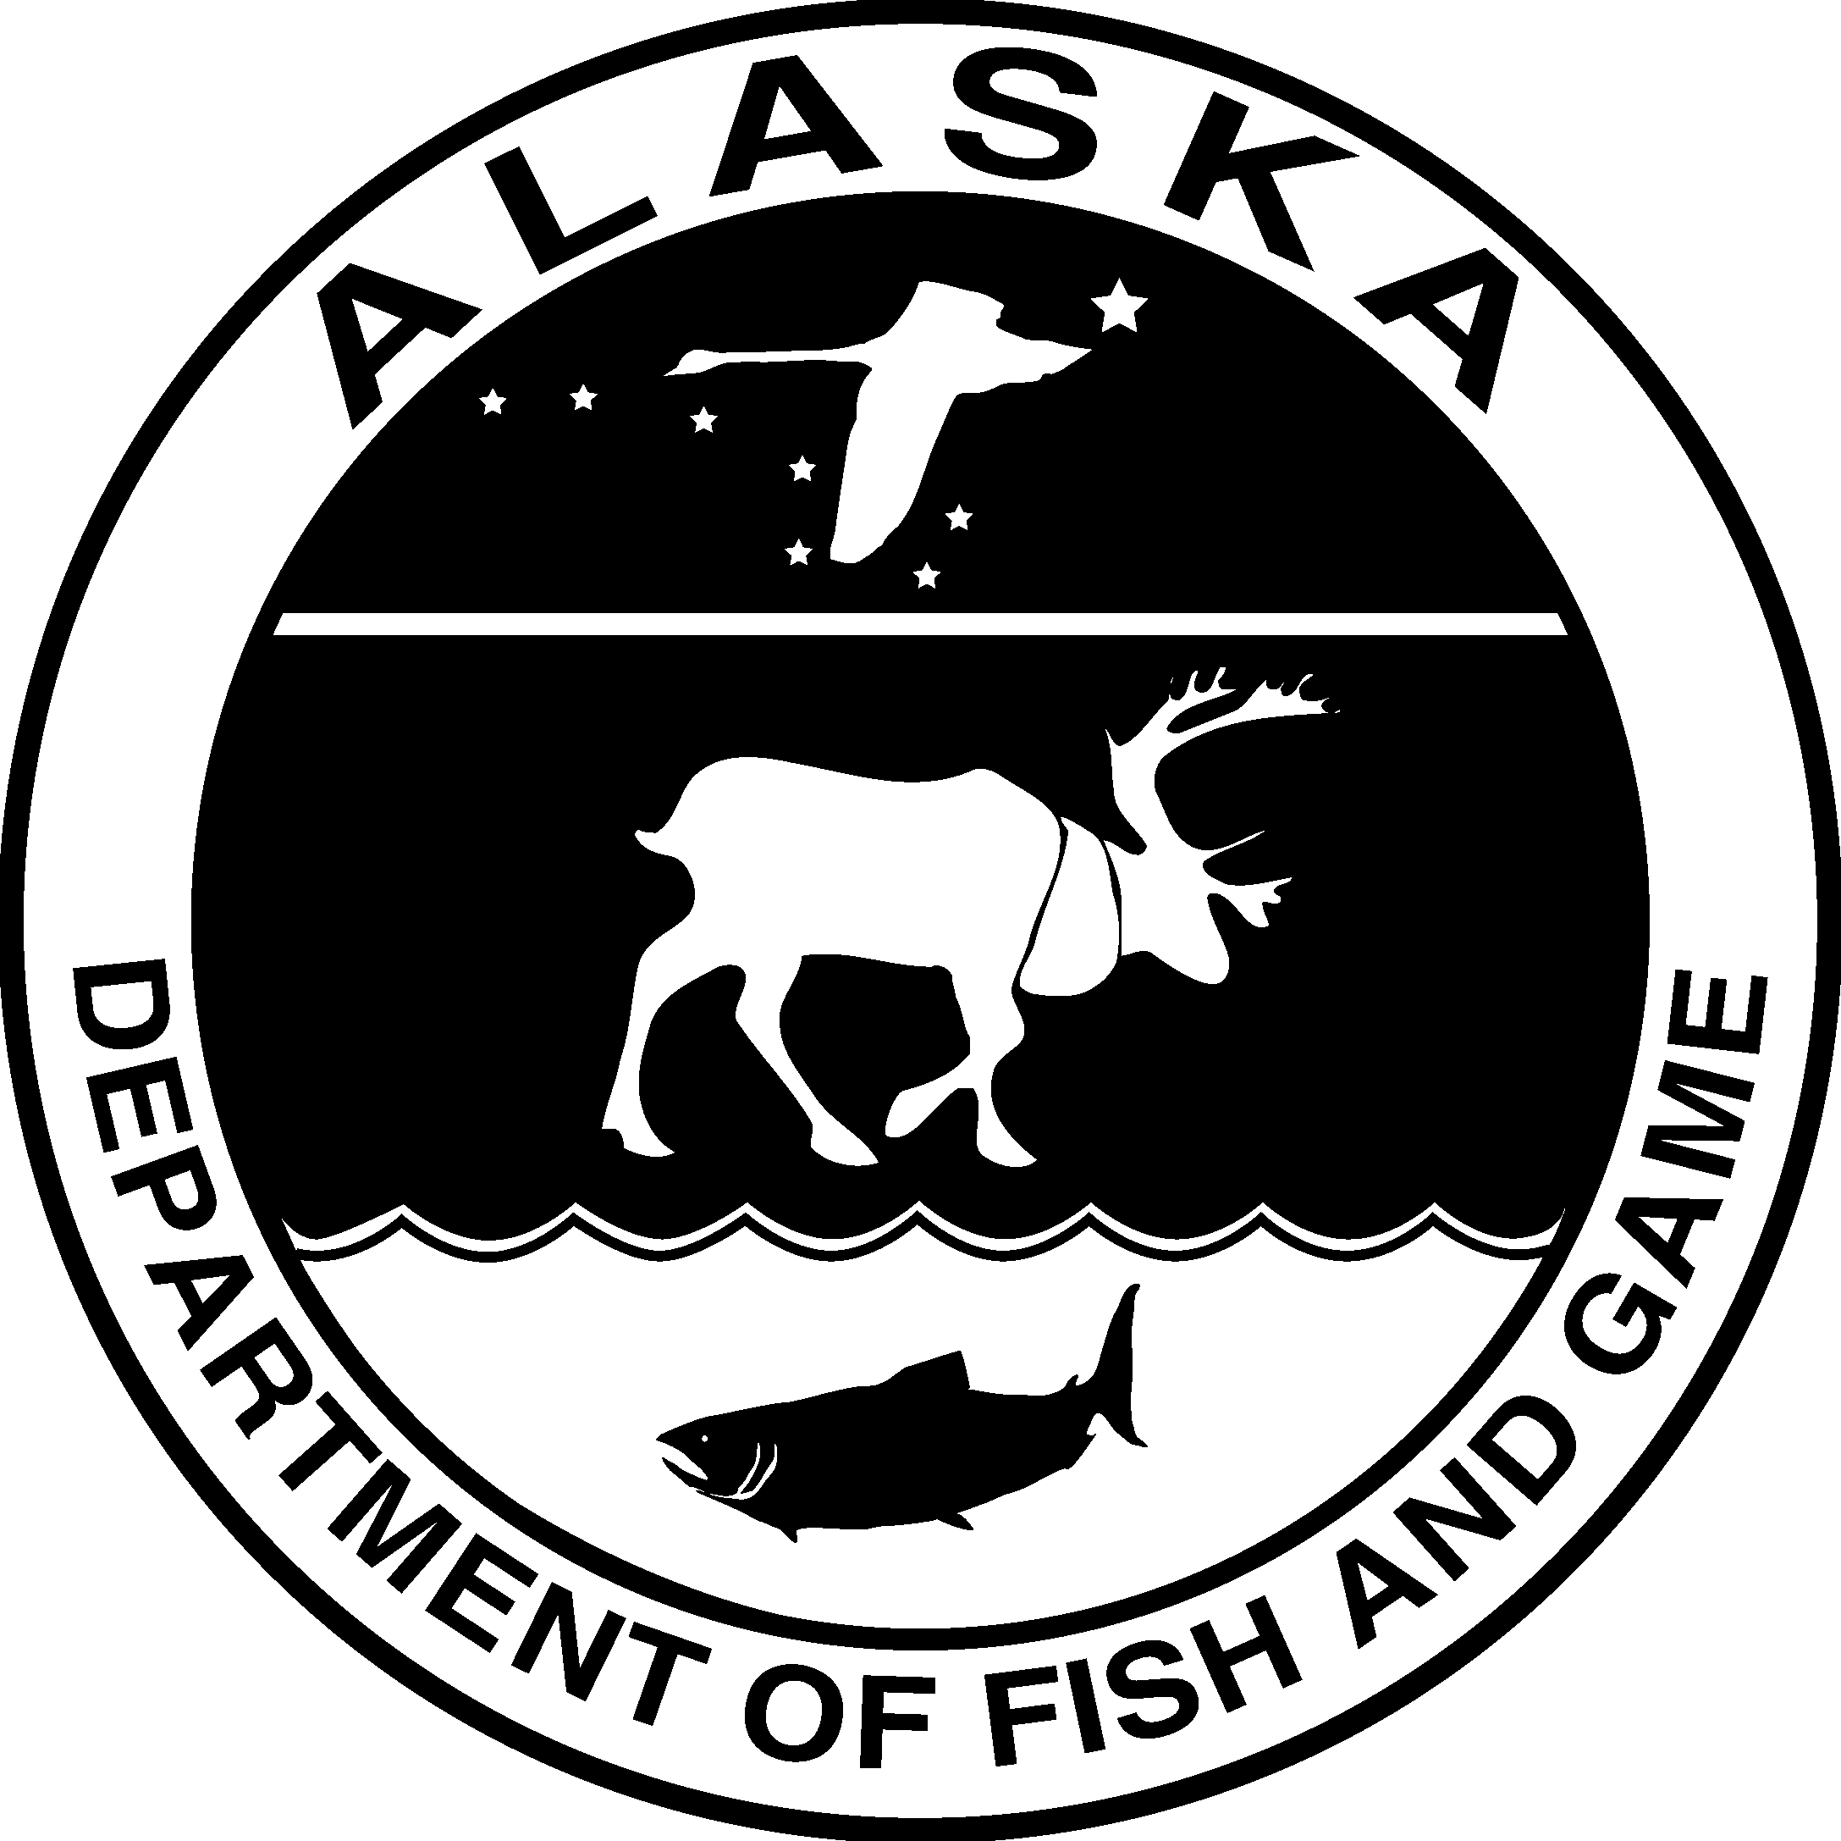

**Symbols and Abbreviations**

The following symbols and abbreviations, and others approved for the Système International d'Unités (SI), are used without definition in the following reports by the Divisions of Sport Fish and of Commercial Fisheries: Fishery Manuscripts, Fishery Data Series Reports, Fishery Management Reports, and Special Publications. All others, including deviations from definitions listed below, are noted in the text at first mention, as well as in the titles or footnotes of tables, and in figure or figure captions.

|  |  |  |  |  |  |
| --- | --- | --- | --- | --- | --- |
| **Weights and measures (metric)** |  | **General** |  | **Mathematics, statistics** |  |
| centimeter | cm | Alaska Administrative |  | *all standard mathematical* |
| deciliter | dL | Code | AAC | *signs, symbols and* |
| gram | g | all commonly accepted |  | *abbreviations* |
| hectare | ha | abbreviations | e.g., Mr., Mrs., | alternate hypothesis | HA |
| kilogram | kg |  | AM, PM, etc. | base of natural logarithm | *e* |
| kilometer | km | all commonly accepted |  | catch per unit effort | CPUE |
| liter | L | professional titles | e.g., Dr., Ph.D., | coefficient of variation | CV |
| meter | m |  | R.N., etc. | common test statistics | (F, t, 2, etc.) |
| milliliter | mL | at | @ | confidence interval | CI |
| millimeter | mm | compass directions: |  | correlation coefficient |  |
|  |  | east | E | (multiple) | R |
| **Weights and measures (English)** |  | north | N | correlation coefficient |  |
| cubic feet per second | ft3/s | south | S | (simple) | r |
| foot | ft | west | W | covariance | cov |
| gallon | gal | copyright |  | degree (angular ) | ° |
| inch | in | corporate suffixes: |  | degrees of freedom | df |
| mile | mi | Company | Co. | expected value | *E* |
| nautical mile | nmi | Corporation | Corp. | greater than | > |
| ounce | oz | Incorporated | Inc. | greater than or equal to |  |
| pound | lb | Limited | Ltd. | harvest per unit effort | HPUE |
| quart | qt | District of Columbia | D.C. | less than | < |
| yard | yd | et alii (and others) | et al. | less than or equal to |  |
|  |  | et cetera (and so forth) | etc. | logarithm (natural) | ln |
| **Time and temperature** |  | exempli gratia |  | logarithm (base 10) | log |
| day | d | (for example) | e.g. | logarithm (specify base) | log2, etc. |
| degrees Celsius | °C | Federal Information |  | minute (angular) | ' |
| degrees Fahrenheit | °F | Code | FIC | not significant | NS |
| degrees kelvin | K | id est (that is) | i.e. | null hypothesis | HO |
| hour | h | latitude or longitude | lat or long | percent | % |
| minute | min | monetary symbols |  | probability | P |
| second | s | (U.S.) | $, ¢ | probability of a type I error |  |
|  |  | months (tables and |  | (rejection of the null |  |
| **Physics and chemistry** |  | figures): first three |  | hypothesis when true) |  |
| all atomic symbols |  | letters | Jan,...,Dec | probability of a type II error |  |
| alternating current | AC | registered trademark | ↓ | (acceptance of the null |  |
| ampere | A | trademark |  | hypothesis when false) |  |
| calorie | cal | United States |  | second (angular) | " |
| direct current | DC | (adjective) | U.S. | standard deviation | SD |
| hertz | Hz | United States of |  | standard error | SE |
| horsepower | hp | America (noun) | USA | variance |  |
| hydrogen ion activity | pH | U.S.C. | United States | population | Var |
| (negative log of) |  |  | Code | sample | var |
| parts per million | ppm | U.S. state | use two-letter |  |  |

parts per thousand ppt,

‰

volts V

watts W

abbreviations (e.g., AK, WA)

***FISHERY MANUSCRIPT NO. XX-XX***

**ESCAPEMENT GOAL REVIEW OF COPPER AND BERING RIVERS, AND PRINCE WILLIAM SOUND PACIFIC SALMON STOCKS, 2020**

by Stormy B. Haught

Alaska Department of Fish and Game, Division of Commercial Fisheries, Cordova

Richard E. Brenner

Alaska Department of Fish and Game, Division of Commercial Fisheries, Juneau

Jack W. Erickson,

Alaska Department of Fish and Game, Division of Commercial Fisheries, Anchorage

James W. Savereide

Alaska Department of Fish and Game, Division of Sport Fish, Fairbanks

and

Timothy R. McKinley

Alaska Department of Fish and Game, Division of Sport Fish, Anchorage

Alaska Department of Fish and Game

Division of Sport Fish, Research and Technical Services 333 Raspberry Road, Anchorage, Alaska, 99518-1565

XXX 2020

The Fishery Manuscript Series was established in 1987 by the Division of Sport Fish for the publication of technically oriented results of several years’ work undertaken on a project to address common objectives, provide an overview of work undertaken through multiple projects to address specific research or management goal(s), or new and/or highly technical methods, and became a joint divisional series in 2004 with the Division of Commercial Fisheries. Fishery Manuscripts are intended for fishery and other technical professionals. Fishery Manuscripts are available through the Alaska State Library and on the Internet: [http://www.adfg.alaska.gov/sf/publications/.](http://www.adfg.alaska.gov/sf/publications/) This publication has undergone editorial and peer review.

*Stormy B. Haught*

*Alaska Department of Fish and Game, Division of Commercial Fisheries, 401 Railroad Avenue, Cordova, AK 99574, USA*

*Richard E. Brenner*

*Alaska Department of Fish and Game, Division of Commercial Fisheries, 1255 W. 8th Street, Juneau, AK 99802, USA*

*Jack W. Erickson*

*Alaska Department of Fish and Game, Division of Commercial Fisheries, 333 Raspberry Road, Anchorage, AK 99518, USA*

*James W. Savereide*

*Alaska Department of Fish and Game, Division of Sport Fish, 1300 College Road, Fairbanks AK, 99701, USA*

*and Timothy R. McKinley*

*Alaska Department of Fish and Game, Division of Sport Fish 333 Raspberry Road, Anchorage, AK 99518, USA*

*This document should be cited as follows:*

*Haught, S. B., R. E. Brenner, J. W. Erickson, J. W. Savereide, and T. R. McKinley. 2017. Escapement goal review of Copper and Bering rivers, and Prince William Sound Pacific salmon stocks, 2017. Alaska Department of Fish and Game, Fishery Manuscript No. 17-10, Anchorage.*

The Alaska Department of Fish and Game (ADF&G) administers all programs and activities free from discrimination based on race, color, national origin, age, sex, religion, marital status, pregnancy, parenthood, or disability. The department administers all programs and activities in compliance with Title VI of the Civil Rights Act of 1964, Section

504 of the Rehabilitation Act of 1973, Title II of the Americans with Disabilities Act (ADA) of 1990, the Age Discrimination Act of 1975, and Title IX of the Education Amendments of 1972.

**If you believe you have been discriminated against in any program, activity, or facility please write:**

ADF&G ADA Coordinator, P.O. Box 115526, Juneau, AK 99811-5526

U.S. Fish and Wildlife Service, 4401 N. Fairfax Drive, MS 2042, Arlington, VA 22203

Office of Equal Opportunity, U.S. Department of the Interior, 1849 C Street NW MS 5230, Washington DC 20240

**The department’s ADA Coordinator can be reached via phone at the following numbers:** (VOICE) 907-465-6077, (Statewide Telecommunication Device for the Deaf) 1-800-478-3648, (Juneau TDD) 907-465-3646, or (FAX) 907-465-6078

**For information on alternative formats and questions on this publication, please contact:**

ADF&G, Division of Sport Fish, Research and Technical Services, 333 Raspberry Rd, Anchorage AK 99518 (907) 267-2375

**TABLE OF CONTENTS**

**Page**

LIST OF TABLES iii

LIST OF FIGURES iii

LIST OF APPENDICES iii

ABSTRACT 1

INTRODUCTION 1

OBJECTIVES 3

OVERVIEW OF STOCK ASSESSMENT METHODS 3

Escapement and Harvest Data 3

Escapement Goal Determination 5

Spawner-recruitment Analysis 5

Percentile Approach 6

STOCK SPECIFIC METHODS, RESULTS AND RECOMMENDATIONS 7

Chinook Salmon 7

Copper River Chinook Salmon 7

Gulkana River Chinook Salmon 8

Chum Salmon 8

Methods 8

Results and Recommendations 9

Chum Salmon Harvest Rates and Percentiles 9

Eastern District Chum Salmon 10

Northern District Chum Salmon 10

Coghill District Chum Salmon 10

Northwestern District Chum Salmon 10

Southeastern District Chum Salmon 11

Coho Salmon 11

Bering River District and Copper River Delta Coho Salmon 11

Pink Salmon 11

Even and Odd Years 11

Methods 12

Results and Recommendations 12

Pink Salmon Harvest Rates and Percentiles 12

Sockeye Salmon 13

Copper River and Copper River Delta Sockeye Salmon 13

Bering River District Sockeye Salmon 13

Coghill Lake Sockeye Salmon 13

Methods and History 13

Results and Recommendations 14

Eshamy Lake Sockeye Salmon 15

ACKNOWLEDGEMENTS 15

REFERENCES CITED 15

TABLES AND FIGURES 19

APPENDIX A: SUPPORTING INFORMATION FOR ESCAPEMENT GOALS FOR SALMON STOCKS IN THE COPPER RIVER, BERING RIVER, AND PRINCE WILLIAM SOUND AREAS 41

# LIST OF TABLES

**Table Page**

1. Summary of recommended escapement goals for Prince William Sound Management Area salmon

stocks, 2017. 20

1. Current escapement goals compared to escapements observed from 2008 through 2016 for Chinook,

chum, coho, pink, and sockeye salmon stocks of the Prince William Sound Management Area. 22

1. Harvest, escapement, and total run size estimates used for high and low estimates of harvest rates of

wild chum salmon in Prince William Sound, Alaska, 1980–2016. 24

1. Harvest, escapement, and total run size estimates used for high and low estimates of harvest rates of

even year wild pink salmon in Prince William Sound, Alaska, 1982–2016. 25

1. Harvest, escapement, and total run size estimates used for high and low estimates of harvest rates of

odd year wild pink salmon in Prince William Sound, Alaska, 1981–2015. 26

1. Total recruits of Coghill Lake sockeye salmon by age class that originated from brood years 1962 to 2016. 27
2. A comparison of Ricker stock-recruitment model estimates from Fair et al. (2011) and the current

analysis that used spawner and recruitment data from brood years 1962–2010. 29

# LIST OF FIGURES

**Figure Page**

1. Prince William Sound Management Area showing commercial fishing districts, salmon hatcheries,

weir locations, and Miles Lake sonar camp 30

1. Optimal yield profiles (OYPs), overfishing profiles (OFPs), and optimal recruitment profiles (ORPs)

for Copper River Chinook salmon 31

1. Estimated harvest, high and low estimates of run size, and high and low estimates of harvest rate (%

harvest of run) for PWS wild chum salmon. 32

1. Annual escapement estimates (dots) for PWS wild chum salmon and 20th percentile (line) of

escapements (1963–2016) for districts; district numbers in parentheses 33

1. Estimated harvest, high and low estimates of run size, and high and low estimates of harvest rate (%

harvest of run) for even year wild pink salmon in PWS 34

1. Annual escapement estimates (dots) for PWS wild even-year pink salmon and 20th and 60th

percentiles (lines) of escapements (1963–2016) for districts; district numbers in parentheses 35

1. Estimated harvest, high and low estimates of run size, and high and low estimates of harvest rate (%

harvest of run) for odd year wild pink salmon in PWS 36

1. Annual escapement estimates (dots) for odd-year wild PWS pink salmon and 25th and 75th percentiles (lines) of escapements (1963–2016) for districts; district numbers in parentheses 37
2. Coghill Lake sockeye salmon yield vs. brood-year spawning escapement 38
3. Plausible spawner-recruit relationships for Coghill Lake sockeye salmon as derived from a Bayesian

stock-recruit analysis for brood years 1962–2010. 39

# LIST OF APPENDICES

**Appendix Page**

A1 Supporting information for analysis of escapement goal for Copper River Chinook salmon. 42

A2 Supporting information for analysis of escapement goal for Prince William Sound chum salmon 43

A3 Supporting information for analysis of escapement goal for Copper River Delta coho salmon 45

A4 Supporting information for analysis of escapement goal for Bering River District coho salmon 47

A5 Supporting information for analysis of escapement goals for PWS even-year pink salmon. 49

A6 Supporting information for analysis of escapement goals for PWS odd-year pink salmon. 52

A7 Supporting information for analysis of escapement goal for Upper Copper River sockeye salmon 55

A8 Supporting information for analysis of escapement goal for Copper River Delta sockeye salmon 57

A9 Supporting information for analysis of escapement goal for Bering River District sockeye salmon 59

A10 Supporting information for analysis of escapement goal for Eshamy Lake sockeye salmon 61

A11 Links to repositories of code used in analysis of escapement goals for Prince William Sound pink and

chum salmon, and Coghill Lake sockeye salmon. 63

# ABSTRACT

This report is a summary of escapement goal reviews and recommendations for major salmon stocks of the Upper Copper River and Prince William Sound Management Areas. Escapement goals were reviewed based on the *Policy for the Management of Sustainable Salmon Fisheries* (5 AAC 39.222) and the *Policy for Statewide Salmon Escapement Goals* (5 AAC 39.223) adopted by the Alaska Board of Fisheries into regulation in 2001. The escapement goal committee reviewed 29 existing escapement goals, including 1 Chinook *Oncorhynchus tshawytscha* , 5 chum *O. keta* , 2 coho *O. kisutch*, 16 pink *O. gorbuscha* (8 goals for each even- and odd-year brood line), and 5 sockeye *O. nerka* salmon stocks. All of the existing goals were adopted in 2002, 2005, 2008, or 2011 except for the 2 coho salmon goals that were adopted in 1991. The escapement goal committee recommends escapement goals be updated for 5 stocks; Copper River Chinook salmon, Copper River Delta and Bering River coho salmon, and Bering River and Coghill Lake sockeye salmon. The escapement goal committee recommends no modifications be made to the other existing salmon escapement goals, and that no goals are eliminated or created at this time.

Key words: Chinook salmon *Oncorhynchus tshawytscha*, chum salmon *O. keta*, sockeye salmon *O. nerka*, coho salmon *O. kisutch*, pink salmon *O. gorbuscha*, escapement goal, biological escapement goal, sustainable escapement goal, Copper River, Bering River, Prince William Sound

# INTRODUCTION

The Prince William Sound Management Area (PWSMA) and the Upper Copper/Upper Susitna Management Area (UCUSMA) encompass all coastal waters and inland drainages entering the north central Gulf of Alaska between Cape Suckling and Cape Fairfield (Figure 1). In addition to Prince William Sound (PWS), these management areas include the Bering and Copper river watersheds with a total adjacent land area of approximately 38,000 square miles. The PWSMA is divided into 11 commercial fishing districts that correspond to local geography and distribution of the 5 species of Pacific salmon *Oncorhynchus* spp. Saltwater subsistence fisheries are tied to commercial fishery openings by time and area, unless otherwise specified through emergency order. Copper River freshwater subsistence fisheries occur on the western Copper River Delta, and in the Chitina (federal subsistence) and Glennallen subdistricts of the Upper Copper River. Personal use fishing only occurs in the Chitina Subdistrict. Sport fisheries are broken out into Prince William Sound and Upper Copper/Upper Susitna management areas.

The primary management objective for all districts is to achieve spawning escapement goals for the major stocks while allowing for an orderly harvest of all fish surplus to spawning requirements and inriver goals. Escapement refers to the annual estimated size of a spawning salmon stock, and is affected by a variety of factors including harvest, predation, disease, and numerous physical and biological characteristics of the environment.

The Alaska Department of Fish and Game (ADF&G) reviews escapement goals for PWSMA and UCUSMA salmon stocks on a schedule corresponding to the Alaska Board of Fisheries (BOF) 3-year cycle for considering area regulatory proposals. Reviews are based on the *Policy for the Management of Sustainable Salmon Fisheries* (SSFP; 5 AAC 39.222) and the *Policy for Statewide Salmon Escapement Goals* (EGP; 5 AAC 39.223). The BOF adopted these policies into regulation during the 2000/2001 cycle to ensure Alaska’s salmon stocks are conserved, managed, and developed using the sustained yield principle. The EGP states that it is ADF&G’s responsibility to document existing salmon escapement goals for all salmon stocks that are currently managed for an escapement goal and to review existing, or propose new, escapement goals on a schedule that conforms to the BOF’s regular cycle of consideration of area regulatory proposals. For this review, there are 2 important terms defined in the SSFP:

5 AAC 39.222 (f)(3) *“biological escapement goal*” or “(BEG)” means the escapement that provides the greatest potential for maximum sustained yield; the BEG will be the primary management objective for the escapement unless an optimal escapement or inriver run goal has been adopted; the BEG will be developed from the best available biological information, and should be scientifically defensible on the basis of available biological information; the BEG will be determined by the department and will be expressed as a range based on factors such as salmon stock productivity and data uncertainty; the department will seek to maintain evenly distributed salmon escapements within the bounds of a BEG; and

5 AAC 39.222 (f)(36) *“sustainable escapement goal*” or “(SEG)” means a level of escapement, indicated by an index or an escapement estimate, that is known to provide for sustained yield over a 5 to 10 year period, used in situations where a BEG cannot be estimated or managed for; the SEG is the primary management objective for the escapement, unless an optimal escapement or inriver run goal has been adopted by the board; the SEG will be developed from the best available biological information; and should be scientifically defensible on the basis of that information; the SEG will be determined by the department and will take into account data uncertainty and be stated as either an “SEG range” or “lower bound SEG”; the department will seek to maintain escapements within the bounds of the SEG range or above the level of a lower bound SEG.

Many salmon escapement goals in this area have been set and evaluated at regular intervals since statehood. This was the ninth time an interdivisional committee reviewed escapement goals for stocks in this area. In 1994 and 1999, committees reviewed and recommended goals with guidance from ADF&G’s *Salmon Escapement Goal Policy* adopted in 1992 (Fried 1994). Since the 2002 review, escapement goals have been compliant with the SSFP and EGP. Due to the comprehensive previous analyses in Bue et al. (2002), Evenson et al. (2008), Fair et al. (2008), Fair et al. (2011), and Moffitt et al. (2014), this review only analyzed goals with recent (2017–2019) data that might have resulted in a substantially different escapement goal from the last review, or those that should be eliminated or established. An interdivisional escapement goal committee (hereafter referred to as the committee), including staff from the Divisions of Commercial Fisheries and Sport Fish, held an initial meeting to discuss and develop recommendations on October 30, 2019. The committee recommended the appropriate type of escapement goal (BEG or SEG), based on the quality and quantity of available data and provided an analysis for recommending escapement goals. The committee met December 20 to review stock assessments and prepare escapement goal recommendations for the PWSMA and UCUSMA meeting in December 2020.

This report describes PWSMA and UCUSMA salmon escapement goals reviewed in 2019 and 2020 and presents information from the previous 3 years in the context of these goals. All committee recommendations are reviewed by ADF&G regional and headquarters staff prior to adoption as escapement goals per the SSFP and EGP. The purpose of this report is to inform the BOF and the public about the review of PWSMA and UCUSMA salmon escapement goals and the committee’s recommendations to the Divisions of Commercial Fisheries and Sport Fish directors.

During the 2019-2020 review process, the committee evaluated escapement goals (or potential goals) for various Chinook *Oncorhynchus tshawytscha*, coho *O. kisutch*, and sockeye *O. nerka* salmon stocks:

* Chinook salmon: Copper River;
* Coho salmon: Bering River and Copper River Delta; and,
* Sockeye salmon: Bering River and Coghill Lake.

# OBJECTIVES

Objectives of the 2019-202 escapement goal review were as follows:

1. review existing goals to determine whether they are still appropriate given (a) new data collected since the last review, (b) current assessment techniques, and (c) current management practices;
2. review the methods used to establish the existing goals to determine whether alternative methods should be investigated;
3. consider additional stocks that may have sufficient data to develop a goal; and
4. recommend new goals if appropriate.

# OVERVIEW OF STOCK ASSESSMENT METHODS

The committee reviewed each of the existing escapement goals using updated escapement and harvest data (if available) collected since the 2017 review. Available escapement, harvest, and age data for each stock originated from research reports, management reports, and unpublished historical databases. Escapement goals for salmon are ideally based on spawner-recruitment relationships (e.g., Beverton and Holt 1957; Ricker 1954), which describe the productivity and carrying capacity of a stock. However, stock assessment data are often not suitable for describing a spawner-recruitment relationship (e.g., no stock-specific harvest data, short escapement time series, or inconsistent escapement monitoring). Therefore, other evaluation methods that use a smaller set of stock assessment data are necessary. Thus, escapement goals are evaluated and revised over time, as improved methods of assessment and goal setting are developed, and when new and better information becomes available.

**ESCAPEMENT AND HARVEST DATA**

Estimates or indices of salmon escapement are obtained using a variety of methods such as aerial surveys, mark–recapture experiments, weir counts, and hydroacoustics (sonar). ADF&G estimates total annual harvests in various ways: commercial fishery from fish ticket receipts, personal use and subsistence fisheries from the return of fishery-specific harvest permits and household surveys; and sport fishery from the annual Statewide Harvest Survey (<http://www.adfg.alaska.gov/sf/sportfishingsurvey>).

Inriver abundance of Copper River Chinook salmon has been monitored by mark–recapture projects since 1999. Total drainage escapement is derived by subtracting inriver harvests from the inriver abundance estimate. Escapements from 1980 to 1998 were indexed in select spawning tributaries using aerial surveys, and these indices were integrated into a state-space age- structured model (Savereide et al. *unpublished*1) to estimate total drainage escapement for the same years. Chinook salmon are primarily harvested commercially, but are also important for subsistence, personal use, and sport fisheries.

Coho salmon escapements to the Copper River Delta (CRD) and Bering River District have been measured as peak index counts from fixed-wing aerial surveys. Although many streams have been surveyed for each coho salmon stock over the years, only surveys conducted annually for the same streams were used to evaluate and set escapement goals: 17 streams in the CRD surveyed back to 1981 and 7 streams in the Bering River District surveyed back to 1984. Coho salmon are primarily harvested commercially, but also by subsistence, personal use, and sport fisheries.

1 Savereide, J. W., M. Tyers, and S. J. Fleischman. *Unpublished*. Run reconstruction, spawner-recruit analysis, and escapement goal recommendation for Chinook salmon in the Copper River. Alaska Department of Fish and Game, Anchorage. Subsequently referred to as Savereide et al. *unpublished*.

The inriver abundance of salmon in the Upper Copper River (UCR) has been monitored at Miles Lake since 1978 using sonar. Beginning in 2005 on the south bank, after a period of comparison, the Bendix side-scan sonar was replaced with dual-frequency identification sonar (DIDSON); this same replacement occurred in 2008 on the north bank (Maxwell et al. 2011). However, even with a reliable measure of inriver abundance, the contribution of the upriver stock to the commercial fishery is not known. Studies in the 1980s based on inherent differences in scale patterns attempted to estimate harvests by stock (UCR vs. CRD vs. Bering River stocks); however, these studies were discontinued because of imprecision in estimates (Marshall et al. 1987). The CRD aerial index of sockeye salmon is estimated as the sum of the peak aerial counts for 17 index streams (Fried 1994). No adjustments were made for area-under-the-curve or stream life. Estimates of contribution by the CRD stock to the Copper River harvests are unavailable. The Bering River District sockeye salmon aerial index is estimated as the sum of the peak aerial counts from 6 survey reaches. Sockeye salmon escapements into Coghill Lake have been visually counted since 1960. From 1960 to 1973, escapements were counted using a partial weir and tower with a full river weir coming into use in 1974. Age compositions from commercial harvests and escapements have been collected since 1962.

**ESCAPEMENT GOAL DETERMINATION**

Escapement goals were evaluated for PWSMA and Upper Copper River stocks using the following methods: (1) Spawner-recruitment Analysis; and (2) Percentile Approach. Spawner and return data were used to estimate escapement goals when the committee determined it had “good” estimates of total return (escapement; age and stock-specific harvest) for a stock. When “good” spawner and return data were available, escapement goals were estimated based on: (1) escapements producing average yields that were 90–100% of maximum sustained yield (MSY) from a spawner-recruitment model, and (2) the Percentile Approach, explained below.

## Spawner-recruitment Analysis

The most commonly used stock-recruitment model, and the model used for these analyses, is described by Ricker (1954).

|  |  |
| --- | --- |
| *R*  *Se**S* | (1) |

where *α* and *β* are model parameters. After log-transforming both sides of the equation, the standard Ricker model was fit to the data using a linear regression equation:

|  |  |
| --- | --- |
| ln(*R* / *S* )  ln(** )  *S* | (2) |

For this review, a Bayesian approach was used to describe the spawner-recruitment relationship and estimate the model parameters for Copper River Chinook salmon (Joy et al. *unpublished*) and Coghill Lake sockeye salmon. State-space age-structured models have been previously used for Ricker stock-recruitment data analysis (Rivot et al. 2001; Fleischman et al.

2013), and ADF&G has applied the Bayesian approach to Ricker models in previous escapement goal studies (e.g., Fleischman and Reimer 2017).

Biological reference points MSY and *SMSY* (the estimate of spawning escapement that produces MSY) represent quantities that maximize yield for the long-term.

We used approximate formulae given by Hilborn and Walters (1992) to estimate *SMSY*:

|  |  |
| --- | --- |
| *S*  ln(** ) 0.5  0.07 ln** .  *MSY * | (3) |

Analysis was performed using JAGS (Just Another Gibbs Sampler; Plummer 2003), which used Markov Chain Monte Carlo (MCMC) methods to sample from the joint posterior of the parameters and posteriors of MSY and *SMSY*. Estimates of *SMSY* to produce 90–100% of MSY came from the median posterior distributions of MSY generated at various escapement intervals.

## Percentile Approach

Many salmon stocks in PWSMA have a SEG developed using the percentile approach. In 2001 Bue and Hasbrouck2 (*unpublished*) developed an algorithm using percentiles of observed escapements, whether estimates or indices, that incorporated contrast in the escapement data and assumed exploitation of the stock. Percentile ranking is the percent of all escapement values that fall below a particular value. To calculate percentiles, escapement data are ranked from the smallest to the largest value, with the smallest value the 0th percentile (i.e., none of the escapement values are less than the smallest). The percentile of all remaining escapement values is cumulative, or a summation, of 1/(*n*-1), where *n* is the number of escapement values. Contrast in the escapement data are the maximum observed escapement divided by the minimum observed escapement. As contrast in the escapements increases, the percentiles used to estimate the SEG are narrowed, primarily from the upper end, to better utilize the yields from the larger runs.

Clark et al. (2014) evaluated the Bue and Hasbrouck (*unpublished*) 4-tier percentile approach and recommended changes to the approach because the tiers are probably sub-optimal as proxies for determining a range of escapements around *SMSY*. Escapements in the lower 60 to 65 percentiles were found to be optimal across a wide range of productivities as well as serial correlation and measurement error in escapements (Clark et al. 2014). Based on this information Clark et al. (2014) recommend percentiles with the following 3 tiers for stocks with low to moderate (less than 0.40) average harvest rates:

Tier 1: high contrast (>8) and high measurement error (aerial and foot surveys) with low to moderate average harvest rates (<0.40), the 20th to 60th percentiles;

Tier 2: high contrast (>8) and low measurement error (weirs, towers) with low to moderate average harvest rates (<0.40), the 15th to 65th percentiles; and

Tier 3: low contrast (8 or less) and high or low measurement error with low to moderate average harvest rates (<0.40), the 5th to 65th percentiles;

2 Bue, B. G. and J. J. Hasbrouck. *Unpublished*. Escapement goal review of salmon stocks of Upper Cook Inlet. Alaska Department of Fish and Game, Report to the Alaska Board of Fisheries, November 2001 (and February 2002), Anchorage. Subsequently referred to as Bue and Hasbrouck u*npublished*.

Use of the Percentile Approach is not recommended for the following situations:

* average harvest rates of 0.40 and greater; and
* very low contrast (4 or less) and high measurement error (aerial or foot surveys)

# STOCK SPECIFIC METHODS, RESULTS AND RECOMMENDATIONS

From this review, the escapement goal committee recommended changes to 5 of the existing salmon escapement goals in PWSMA and UCUSMA (Table 1). The committee specifically reviewed all the recent escapements (Table 2) and current methodology to determine whether there was sufficient new information or methodology to warrant a review of the existing goal. Details for these updated analyses and recommendations are provided below. All data sets were updated (Tables 1–4 and Appendices A1–A4) and most were reevaluated using new methodologies. A comprehensive review of goal performance for all salmon stocks from 2008 to 2019 is found in Table 2.

**CHINOOK SALMON**

## Copper River Chinook Salmon

The current lower bound SEG of 24,000 or more spawners was implemented in 2003 (Bue et al. 2002). Since the lower bound SEG was established Chinook salmon escapements achieved 24,000 or more salmon in 11 out of 16 years (Appendix A1). The escapement goal was originally established with very few direct estimates of escapement, and was set as a lower bound SEG to keep escapements near the historical average, which were estimated for 1980–1998 using a catch-age model (Deriso et al. 1985; Savereide and Quinn 2004). Multiple approaches were explored using the catch-age model and the approach that allowed for measurement error in the pooled catch-age data from all fisheries and brood-year return proportions to vary over time produced parameter estimates with high precision and low bias; estimates of *SMSY* from all 4 approaches of the catch-age model ranged from 14,388 to 19,711 (Savereide 2001). Since 1999, mark–recapture techniques have been used to estimate inriver abundance, and total drainage escapement is then derived by subtracting inriver harvest. There are only 20 escapement estimates available (1999–2018 mark–recapture estimates) and these estimates exhibit a low contrast (4.7), which provides limited information for estimating a stock-recruit relationship, and hence a BEG. This goal has been reviewed every BOF cycle since 2002 (Evenson et al. 2008; Fair et al. 2008, 2011; Moffitt et al. 2014). During these reviews, the committee evaluated stock- recruit data, the percentile approach (Clark et. al 2014), and habitat-based models (Liermann et al. 2010) as means of setting an escapement goal. During this review a state-space model that simultaneously reconstructs runs and fits a spawner-recruit model to estimate total return, escapement, and recruitment of Copper River Chinook salmon from 1980 to 2018 was completed (Joy et al. *unpublished*). The model uses harvest, age composition, and relative and absolute measures of inriver run abundance to estimate parameters that describe the production relationship for this stock. Uncertainty from the run reconstruction is passed through to the spawner-recruit analysis and all relevant data are considered and weighted by their precision. The model accommodates missing data, measurement error in the data, absolute and relative abundance indices, and changes in age at maturity. Additionally, a similar state-state model was used on a subset of data from 1999 to 2018 that used only mark-recapture estimates of escapement (and excluded abundance indices used in the full data set) to determine how optimal values would differ when only considering more recent years and only high quality data. This second analysis is referred to as the ’99 analysis. The state-space model from the full analysis (1980-2018), similar to the catch- age model, estimates *SMSY* to be lower than the current lower bound SEG. The estimated median *SMSY* from the state-space model is 22,844 fish and 27,057 from the ’99 analysis. Optimal yield profiles indicate an escapement of 22,844 Copper River Chinook salmon has a 64% probability of achieving 90% MSY in the full analysis and a 70% chance of achieving 90% MSY in the ’99 analysis. 21,000 fish has a 68 and 65% of achieving 90% of MSY in the full and ’99 analysis, respectively, while 31,000 fish has a 73 and 88% probability of achieving 70% of MSY in the two analysis, respecitvely (Figure 2; Joy et al. *unpublished*). **Based on these results the committee recommends an SEG range of 21,000 to 31,000 Chinook salmon, which has a high probability of producing sustainable yields.**

**COHO SALMON**

### Bering River

The current SEG (13,000–33,000) for this stock was adopted in 2003 and was developed using the percentile approach of Bue and Hasbrouck (*unpublished*) and peak aerial surveys from 7 index systems. For this review the data set was updated through 2018 and recommendations from Clark et al. (2014) and yield analysis were applied to determine escapements that provide sustained yield (Appendix A2). This stock is high contrast (14.4) with an average harvest rate likely greater than 40% and high measurement error (aerial surveys). A percentile approach is not recommended for stocks with average harvest rates of .4 or greater (Clarke et al. 2014).

We calculated yields from complete brood years (1982-2013) and generated Markov yield tables. Yield analysis indicated highest (>100,000) mean yields occur within an aerial escapement index range of 10,000–20,000, and that escapements indices from 5,000 to 25,000 produce average yields greater than 90,000. **Based on these results the committee recommends the Bering River coho salmon SEG be updated to 13,000–25,000. The change in this goal has allocative implications for Copper River Delta subsistence, commercial, and sport fisheries.**

### Copper River Delta

The current SEG (32,000–67,000) for this stock was adopted in 2003 and was developed using the percentile approach of Bue and Hasbrouck (*unpublished*) and peak aerial escapement counts from 17 index systems. For this review the data set was updated through 2018, and an additional index system (Pleasant Creek), which has been flown consistently since 1982, was added. Recommendations from Clark et al. (2014) and yield analysis were applied to determine escapements that provide sustained yield (Appendix A3). This stock is low contrast (4.1) with an average harvest rate likely greater than 40% and high measurement error (aerial surveys). A percentile approach is not recommended for stocks with average harvest rates of .4 or greater (Clarke et al. 2014).

We calculated yields from complete brood years (1981–2013) and generated Markov yield tables. Yield analysis indicated highest mean yields (>350,000) occur within an aerial escapement index range of 40,000–50,000, and that escapement indices from 20,000 to 50,000 produce average yields greater than 218,000. Based on these results the committee recommends the Copper River Delta coho salmon SEG be updated to a range of 32,000–50,000. The change in this goal has allocative implications for Copper River Delta subsistence, commercial, and sport fisheries.

**SOCKEYE SALMON**

### Bering River Sockeye Salmon

The current SEG (15,000-33,000) for this stock was adopted in 2012 (Fair et al. 2011) and was developed from peak aerial surveys using the percentile approach of Bue and Hasbrouck (*unpublished*). For this review the data set was updated through 2018 and the 3-tier percentile method was applied (Appendix A4). This method was used because the tiers from the Bue and Hasbrouck approach were deemed to provide less optimal proxies for determining the range of escapements around Smsy (Clark et al. 2014). This stock is high contrast (12.8), with a moderate average harvest rate (0.27) and high measurement error (aerial surveys), resulting in a tier 1 percentile recommendation (20th and 60th percentiles). Based on these results the committee recommends the Bering River sockeye salmon SEG be updated to a range of 15,000–24,000. The change in this goal has allocative implications for Copper River Delta subsistence, commercial, and sport fisheries.

### Coghill Lake Sockeye Salmon

## Methods and History

The current Coghill Lake sockeye salmon SEG was adopted in 2012 after extensive analyses that included comparisons of yield from the Ricker and Beverton-Holt models (Fair et al. 2011). In their analysis, the authors noted the absence of a clear trend in empirical estimates of yield (recruits minus brood-year spawners) across a wide range of spawning escapements. In establishing the new goal it was determined that broadening the SEG range (from the previous range of 20,000–40,000 spawners to a new range of 20,000–60,000 spawners) would allow for greater flexibility by fisheries managers without substantially risking a decrease in yields. It has been suggested that the productivity of Coghill Lake sockeye salmon might be influenced by abiotic factors that include a short ice-free period, cold temperatures, high inorganic turbidity, and meromictic characteristics that can also be disrupted by unpredictable stochastic processes (Edmundson et al. 1992, 1997). However, there was also some evidence of density-dependent effects at high levels of spawning escapement, which resulted in depleted zooplankton abundances for rearing juvenile sockeye salmon (Edmundson et al. 1997; Koenings and Kyle 1997).

For this escapement goal review, we updated escapement and return data through 2019 (Table 3; brood years 1962–2014 used) and reanalyzed the Ricker spawner-recruitment relationship in a Bayesian framework. See Fleischman and Reimer (2017), Fleischman et al. (2013), and Staton et al. (2016) for salmon stock assessments that used similar Bayesian approaches for estimating Ricker model parameter values and informing management reference points.

## Results and Recommendations

As was noted by Fair et al. (2011), measured yield of Coghill Lake wild sockeye salmon has been relatively constant across the entire range of historical escapements, suggesting that a large range of escapements could result in high or low yields (Haught et al. 2017). From our updated Ricker analysis (Figure 4, Table 4), the point estimate of escapement believed to result in maximum yield (*SMSY* of 56,568) was very close to the estimate of 59,000 from Bue et al. 2002 and 59,677 from Fair et al. (2011). Parameter estimates (alpha, beta, sigma) for the Bayesian Ricker model were also similar to those presented in Fair et al. (2011) and the confidence bounds of these parameter estimates were similarly large. Thus, updated spawner and return data since the 2002 and 2011 reviews has not appreciably changed model output or recommendations for *SMSY*. However, of note is that these estimates of SMSY are very close to the upper bound (60,000) of the existing goal.

Even though there is considerable uncertainty surrounding the estimates of Smsy, the estimates are robust across analyses and measured yields have remained relatively constant across the range of historical escapements. This suggests a large range of escapements can result in high or low yields. In addition, the yield and overfishing profiles from the latest SRA suggest that similar historical yields can be observed at higher levels of escapement with a much lower probability of overfishing. Increasing the upper bound to 75,000 would result in a ~90% probability of achieving at least 80% of MSY (and a 66% probability of achieving at least 90% of MSY). Tthere is some evidence that multiple years of high spawning escapements into Coghill Lake may result in density-dependent effects including depleted zooplankton abundances for rearing juvenile sockeye salmon (Edmundson et al. 1997; Koenings and Kyle 1997) and we therefore suggest that consecutive escapements at the upper end of the goal be avoided. Because only the upper bound of the goal is being increased, the change in this goal should not result in allocative implications to fisheries.

# ACKNOWLEDGEMENTS

The authors thank other core members of the escapement goal committee: Daniel Bosch, Jeremy Botz, Robert Clark, Steve Fleischman, James Hasbrouck, Bert Lewis, Andrew Munro, Charles Russell, Mark Somerville, Bill Templin, Matt Tyers, Tom Vania, Tim Viavant, and Xinxian Zhang for their assistance reviewing and establishing escapement goals recommendations.

# REFERENCES CITED

Bernard, D. R., J. J. Hasbrouck, B. G. Bue, and R. A. Clark. 2009. Estimating risk of management error from precautionary reference points (PRPs) for non-targeted salmon stocks. Alaska Department of Fish and Game, Special Publication No. 09-09, Anchorage.

Beverton, R. J. H., and S. J. Holt. 1957. On the dynamics of exploited fish populations. Fisheries Investigation Series 2, Vol. 19 U.K. Ministry of Agriculture and Fisheries, London.

Bue, B. G., S. M. Fried, S. Sharr, D. G. Sharp, J. A. Wilcock, and H .J. Geiger. 1998. Estimating salmon escapement using area-under-the-curve, aerial observer efficiency, and stream-life estimates: The Prince William Sound example. North Pacific Anadromous Fisheries Commission Bulletin 1:240–250.

Bue, B. G., J. J. Hasbrouck, and M. J. Evenson. 2002. Escapement goal review of Copper River and Bering Rivers, and Prince William Sound Pacific salmon stocks. Alaska Department of Fish and Game, Division of Commercial Fisheries, Regional Information Report 2A02-35, Anchorage.

Brady, J. A., S. Sharr, K. Roberson, and F. M. Thompson. 1987. Prince William Sound area annual finfish management report, 1986. Alaska Department of Fish and Game, Division of Commercial Fisheries, Cordova, Alaska.

Brenner, R. E.*,* S. D. Moffitt*,* and W. S. Grant*.* 2012*.* Straying of hatchery salmon in Prince William Sound, Alaska*.* Environmental Biology of Fishes 94*:*179*–*195*.*

Clark, R. A., D. M. Eggers, A. R. Munro, S. J. Fleischman, B. G. Bue, and J. J. Hasbrouck. 2014. An evaluation of the percentile approach for establishing Sustainable Escapement Goals in lieu of stock productivity information. Alaska Department of Fish and Game, Fishery Manuscript No. 14-06, Anchorage.

Deriso, R. B., T. J. Quinn II, and P. R. Neal. 1985. Catch-age analysis with auxiliary information. Canadian Journal of Fisheries and Aquatic Sciences 42:815–824.

Edmundson, J. A., G. B. Kyle, and T. M. Willette. 1992. Limnological and fisheries assessment of Coghill Lake relative to sockeye salmon (*Oncorhynchus nerka*) production and lake fertilization. Alaska Department of Fish and Game, Fisheries Rehabilitation Enhancement and Development Division Report 118, Juneau.

**REFERENCES CITED (Continued)**

Edmundson, J. A., G. B. Kyle, S. R. Carlson, and P. A. Shields. 1997. Trophic–level responses to nutrient treatment of meromictic and glacially influenced Coghill Lake. Alaska Fisheries Research Bulletin 4:136–153.

Evenson, M. J., J. J. Hasbrouck, S. D. Moffitt, and L. Fair. 2008. Escapement goal review for Copper River Bering River, and Prince William Sound salmon stocks. Alaska Department of Fish and Game, Fishery Manuscript No. 08-01, Anchorage.

Fair, L. F., S. D. Moffitt, M. J. Evenson, and J. W. Erickson. 2011. Escapement goal review of Copper and Bering rivers, and Prince William Sound Pacific salmon stocks, 2011. Alaska Department of Fish and Game, Fishery Manuscript No. 11-07, Anchorage.

Fair, L. F., S. D. Moffitt, M. J. Evenson, and J. Erickson. 2008. Escapement goal review of Copper and Bering rivers, and Prince William Sound Pacific salmon stocks, 2008. Alaska Department of Fish and Game, Fishery Manuscript No. 08-02, Anchorage.

Fleischman, S. J., and A. M. Reimer. 2017. Spawner-recruit analyses and escapement goal recommendations for Kenai River Chinook salmon. Alaska Department of Fish and Game, Fishery Manuscript Series No. 17-02, Anchorage.

Fleischman, S. J., M. J. Catalano, R. A. Clark, and D. R. Bernard. 2013. An age-structured state-space stock– recruit model for Pacific salmon (*Oncorhynchus* spp.). Canadian Journal of Fisheries and Aquatic Sciences 70:401–414.

Fried, S. M. 1994. Pacific salmon spawning escapement goals for the Prince William Sound, Cook Inlet, and Bristol Bay areas of Alaska. Alaska Department of Fish and Game, Commercial Fisheries Management and Development Division, Special Publication No. 8, Juneau.

Fried, S. M., B.G. Bue, S. Sharp, and S. Sharr. 1998. Injury to spawning areas and evaluation of spawning escapement enumeration of pink salmon in Prince William Sound, Alaska, Exxon Valdez damage assessment (Fish/Shellfish NRDA Study 1) and restoration (restoration studies 9 and 60B) study final report, Alaska Department of Fish and Game, Division of Commercial Fisheries, Anchorage.

Hilborn, R., and C. J. Walters. 1992. Quantitative fisheries stock assessment: choice, dynamics and uncertainty.

Chapman and Hall, New York, NY.

Joyce T. L., and D. G. Evans. 1999. Otolith marking of pink salmon in Prince William Sound salmon hatcheries, *Exxon Valdez* oil spill restoration final report (Restoration Project 99188). Alaska Department of Fish and Game, Division of Commercial Fisheries, Cordova and Anchorage, Alaska.

Joyce, T., and R. Riffe. 1998. Summary of Pacific salmon coded wire tag and thermal mark application and recovery, Prince William Sound, 1997. Alaska Department of Fish and Game, Division of Commercial Fisheries Management and Development Division, Regional Information Report 2A98–06, Anchorage.

Koenings, J. P., and G. B. Kyle. 1997. Consequences to juvenile sockeye salmon and the zooplankton community resulting from intense predation. Alaska Fisheries Research Bulletin 4:120–135.

Liermann, M. C., R. Sharma, C. K. Parken. 2010. Using accessible watershed size to predict management parameters for Chinook salmon *Oncorhynchus tshawytscha*, populations with little or no spawner-recruit data: A Bayesian hierarchical modeling approach. Fisheries Management and Ecology 17:40–51.

Marshall, S., D. Bernard, R. Conrad, B. Cross, D. McBride, A. McGregor, S. McPherson, G. Oliver, S. Sharr, and B. Van Alen. 1987. Application of scale patterns analysis to the management of Alaska’s sockeye salmon (*Oncorhynchus nerka*) fisheries. Pages 307–326 [*In*] H. D. Smith, L. Margolis and C. C. Wood, editors. Sockeye salmon (*Oncorhynchus nerka*) population biology and future management. Canadian Special Publication of Fisheries and Aquatic Science 96.

Maxwell, S. L., A. V. Faulkner, L. Fair, and X. Zhang. 2011. A comparison of estimates from 2 hydroacoustic systems used to assess sockeye salmon escapement in 5 Alaska Rivers. Alaska Department of Fish and Game, Fishery Manuscript Series No. 11-02, Anchorage.

**REFERENCES CITED (Continued)**

Moffitt, S. D., R. E. Brenner, J. W. Erickson, M. J. Evenson, R. A. Clark, and T. R. McKinley. 2014. Escapement goal review of Copper and Bering rivers, and Prince William Sound Pacific salmon stocks, 2014. Alaska Department of Fish and Game, Fishery Manuscript No. 14-05, Anchorage.

Pirtle, R. B. 1979. Annual management report 1978 Prince William Sound Area Region II. Alaska Department of Fish and Game, Division of Commercial Fisheries, Cordova, Alaska.

Pirtle, R. B. 1981. A compilation of historical sockeye salmon spawning escapement estimates from Prince William Sound. Alaska Department of Fish and Game, Division of Commercial Fisheries, Data Report No. 10, Cordova.

Plummer, M. 2003. JAGS: A program for analysis of Bayesian graphical models using Gibbs sampling. Ricker, W. E. 1954. Stock and recruitment. Journal of the Fisheries Research Board of Canada 11:559–623.

Rivot, E., E. Prévost, and E. Parent. 2001. How robust are Bayesian posterior inferences based on a Ricker model with regards to measurement errors and prior assumptions about parameters? Canadian Journal of Fisheries and Aquatic Sciences 58:2284–2297.

Savereide, J. W. 2001. An age structured model for assessment and management of Copper River Chinook salmon.

Master’s Thesis, University of Alaska Fairbanks.

Savereide, J. W., and T. J. Quinn, II. 2004. An age structured assessment model for Chinook salmon (*Oncorhynchus tshawytscha*). Canadian Journal of Fisheries and Aquatic Sciences 61:974–985.

Staton, B. A., M. J. Catalano, and S. J. Fleischman. 2016. From sequential to integrated Bayesian analyses: Exploring the continuum with a Pacific salmon spawner-recruit model. Fisheries Research 186:237-247.

Ward E. J., R. E. Brenner, M. Adkison, J. Couture, S. C. Dressel, M. A. Litzow, S. Moffitt. 2017. Evaluating signals of oil spill impacts, climate, and species interactions in Pacific herring and Pacific salmon populations in Prince William Sound and Copper River, Alaska. PLoS ONE 12(3): e0172898. <https://doi.org/10.1371/journal.pone.0172898>

# TABLES AND FIGURES

20

Table 1.–Summary of recommended escapement goals for Prince William Sound Management Area salmon stocks, 2017.

|  |  |  |  |  |  |  |  |  |
| --- | --- | --- | --- | --- | --- | --- | --- | --- |
| Current escapement goal | | | |  |  | Recommended escapement goa | | l |
| System | Goal | Type | Year adopted |  | Goal | Type | Data | Action |
| Chinook salmon |  |  |  |  |  |  |  |  |
| Copper River | 24,000 | LB SEG | 2003 |  | 21,000–31,000 | SEG | Mark–recapture | Establish SEG range |
| Coho salmon |  |  |  |  |  |  |  |  |
| Copper River Delta | 32,000–67,000 | SEG | 2003 |  | 32,000-62,000 | SEG | Aerial surveys | Lower the upper bound |
| Bering River | 13,000–33,000 | SEG | 2003 |  | 13,000-25,000 | SEG | Aerial surveys | Lower the upper bound |
| Sockeye salmon |  |  |  |  |  |  |  |  |
| Upper Copper River | 360,000–750,000 | SEG | 2012 |  |  |  | Sonar | No Change |
| Copper River Delta | 55,000–130,000 | SEG | 2003 |  |  |  | Aerial Surveys | No Change |
| Bering River | 15,000–33,000 | SEG | 2012 |  |  |  | Aerial Surveys | No Change |
| Coghill Lake | 20,000–60,000 | SEG | 2012 |  |  |  | Weir | No Change |
| Eshamy Lake | 13,000–28,000 | BEG | 2009 |  |  |  | Weir | No Change |

21

22

Table 2.–Current escapement goals compared to escapements observed from 2010 through 2018 for Chinook, coho, and sockeye salmon stocks of the Prince William Sound Management Area.

|  |  |  |  |  |  |  |  |  |  |  |  |  |  |  |
| --- | --- | --- | --- | --- | --- | --- | --- | --- | --- | --- | --- | --- | --- | --- |
|  | 2017 goal range | |  | Initial |  |  |  |  |  |  |  |  |  |  |
| Species/System | Lower | Upper | Type | year | 2010 | 2011 | 2012 | 2013 | 2014 | 2015 | 2016 | 2017 | 2018 | 2019a |
| Chinook salmon |  |  |  |  |  |  |  |  |  |  |  |  |  |  |
| Copper River | 24,000 |  | lower bound SEG | 2003 | 16,771 | 27,936 | 27,846 | 29,013 | 20,689 | 26,751 | 12,430 | 33,644 | 42,678 | 35,138 |
| Coho salmon |  |  |  |  |  |  |  |  |  |  |  |  |  |  |
| Copper River Delta | 32,000 | 67,000 | SEG | 2003 | 41,077 | 38,145 | 36,735 | 34,630 | 44,040 | 42,065 | 76,200 | 43,760 | 53,800 | 36,420 |
| Bering River | 13,000 | 33,000 | SEG | 2003 | 21,311 | 18,890 | 15,605 | 18,820 | 26,475 | 15,550 | 26,150 | 30,650 | 26,525 | 10,015 |
| Sockeye salmon |  |  |  |  |  |  |  |  |  |  |  |  |  |  |
| Upper Copper River | 360,000 | 750,000 | SEG | 2012 | 607,140 | 954,010 | 860,253 | 864,169 | 930,145 | 513,143 | 460,295 | 495,779 | 719,526 | 360,000 |
| Copper River Delta | 55,000 | 130,000 | SEG | 2003 | 72,367 | 66,850 | 75,705 | 64,205 | 66,665 | 51,550 | 56,500 | 58,470 | 61,825 | 55,000 |
| Bering River | 15,000 | 33,000 | SEG | 2012 | 4,951 | 28,530 | 18,290 | 23,900 | 14,885 | 22,705 | 16,390 | 19,115 | 13,300 | 17,630 |
| Coghill Lake | 20,000 | 60,000 | SEG | 2012 | 24,312 | 102,359 | 74,978 | 17,231 | 21,836 | 13,684 | 8,708 | 50,462 | 62,295 | 32,247 |
| Eshamy Lake | 13,000 | 28,000 | BEG | 2009 | 24,129 | NA | 4,500 | 7,500 | 4,400 | 5,816 | NC | NC | NC | 13,000 |

*Note*: Shaded cells show years when escapement goals were not met.

a 2017 estimates are preliminary and incomplete for most stocks.

b Prior to 2012, pink salmon goals were soundwide goals within a brood line (even and odd years).

c Insufficient aerial survey coverage.

d A video weir was operated from 2013 to present. The numbers represent an unknown fraction of the total annual escapement.

Table 3.–Total recruits of Coghill Lake sockeye salmon by age class that originated from brood years 1962 to 2016.

|  |  |  |  |  |  |  |  |  |  |
| --- | --- | --- | --- | --- | --- | --- | --- | --- | --- |
| Age at return in years | | | | | | | | | |
|  | 3 | | 4 | 5 | 5 | 6 |  |  |  |
| Brood year | Escapement | 1.1 | 1.2 | 1.3 | 2.2 | 2.3 | BY recruitsa | R/S | Yield b |
| 1962 b | 26,866 | 0 | 17,815 | 34,021 | 2,195 | 489 | 54,520 | 2.03 | 27,654 |
| 1963 b | 63,984 | 159 | 4,391 | 53,756 | 318 | 5,325 | 63,949 | 1 | (35) |
| 1964 b | 22,200 | 0 | 32,538 | 124,343 | 4,154 | 2,095 | 163,130 | 7.35 | 140,930 |
| 1965 b | 62,500 | 224 | 25,199 | 48,915 | 1,634 | 1,694 | 77,666 | 1.24 | 15,166 |
| 1966 b | 82,500 | 267 | 9,913 | 54,766 | 303 | 20,909 | 86,158 | 1.04 | 3,658 |
| 1967 b | 33,000 | 0 | 3,751 | 140,138 | 1,396 | 8,047 | 153,332 | 4.65 | 120,332 |
| 1968 b | 11,800 | 0 | 22,526 | 108,120 | 3,219 | 3,643 | 137,508 | 11.65 | 125,708 |
| 1969 b | 81,000 | 0 | 12,896 | 60,811 | 7,908 | 10,133 | 91,748 | 1.13 | 10,748 |
| 1970 b | 35,200 | 0 | 49,280 | 158,164 | 8,803 | 4,619 | 220,866 | 6.27 | 185,666 |
| 1971 b | 15,000 | 115 | 5,604 | 32,566 | 2,782 | 5,661 | 46,728 | 3.12 | 31,728 |
| 1972 b | 51,000 | 0 | 29,452 | 164,079 | 6,691 | 18,346 | 218,568 | 4.29 | 167,568 |
| 1973 b | 55,000 | 0 | 25,454 | 203,097 | 3,332 | 1,805 | 233,688 | 4.25 | 178,688 |
| 1974 | 22,334 | 455 | 21,031 | 76,250 | 10,499 | 2,590 | 110,825 | 4.96 | 88,491 |
| 1975 | 34,855 | 0 | 38,347 | 136,670 | 7,713 | 8,799 | 191,528 | 5.5 | 156,673 |
| 1976 | 9,056 | 90 | 52,434 | 99,913 | 12,717 | 8,377 | 173,531 | 19.16 | 164,475 |
| 1977 | 31,562 | 1,981 | 137,083 | 1,108,256 | 1,773 | 1,956 | 1,251,048 | 39.64 | 1,219,486 |
| 1978 | 42,284 | 656 | 8,799 | 51,329 | 2,139 | 7,381 | 70,303 | 1.66 | 28,019 |
| 1979 | 48,281 | 270 | 17,439 | 105,297 | 6,351 | 21,049 | 150,407 | 3.12 | 102,126 |
| 1980 | 142,253 | 162 | 37,780 | 344,020 | 51,572 | 40,122 | 473,656 | 3.33 | 331,403 |
| 1981 | 156,112 | 436 | 92,478 | 355,917 | 14,590 | 32,817 | 496,238 | 3.18 | 340,126 |
| 1982 | 180,314 | 155 | 58,604 | 546,985 | 5,829 | 586 | 612,159 | 3.39 | 431,845 |
| 1983 | 38,783 | 71 | 11,755 | 86,810 | 448 | 7,213 | 106,297 | 2.74 | 67,514 |
| 1984 | 63,622 | 1,347 | 64,775 | 133,744 | 2,112 | 1,108 | 203,086 | 3.19 | 139,464 |
| 1985 | 163,342 | 31 | 1,682 | 12,951 | 1,170 | 764 | 16,598 | 0.1 | (146,744) |
| 1986 | 74,135 | 34 | 4,372 | 17,266 | 83 | 5,164 | 26,918 | 0.36 | (47,217) |
| 1987 | 187,263 | 20 | 2,169 | 53,697 | 1,419 | 2,749 | 60,053 | 0.32 | (127,210) |
| 1988 | 72,023 | 21 | 6,913 | 41,717 | 1,246 | 598 | 50,495 | 0.7 | (21,528) |
| 1989 | 36,881 | 11 | 2,596 | 4,662 | 406 | 1,735 | 9,410 | 0.26 | (27,471) |

-continued-

Table 3.–Page 2 of 2.

|  |  |  |  |  |  |  |  |  |  |
| --- | --- | --- | --- | --- | --- | --- | --- | --- | --- |
| Age at return in years | | | | | | | | | |
|  | 3 | | 4 | 5 | 5 | 6 |  |  |  |
| Brood year | Escapement | 1.1 | 1.2 | 1.3 | 2.2 | 2.3 | BY recruitsa | R/S | Yield b |
| 1990 | 8,250 | 49 | 3,519 | 19,808 | 1,018 | 1,733 | 26,127 | 3.17 | 17,877 |
| 1991 | 9,701 | 106 | 38,575 | 113,543 | 942 | 643 | 153,809 | 15.85 | 144,108 |
| 1992 | 29,642 | 160 | 14,841 | 97,317 | 321,531 | 1,488 | 114,127 | 3.85 | 84,485 |
| 1993 | 9,232 | 122 | 8,467 | 58,365 | 230 | 282 | 67,466 | 7.31 | 58,234 |
| 1994 | 7,264 | 0 | 2,313 | 9,645 | 3,999 | 11,982 | 27,939 | 3.85 | 20,675 |
| 1995 | 30,382 | 974 | 133,941 | 177,124 | 2,379 | 3,090 | 317,508 | 10.45 | 287,126 |
| 1996 | 38,693 | 244 | 22,428 | 108,519 | 1,697 | 583 | 133,471 | 3.45 | 94,778 |
| 1997 | 35,010 | 4 | 12,566 | 30,255 | 318 | 1,593 | 44,736 | 1.28 | 9,726 |
| 1998 | 27,050 | 154 | 21,013 | 67,785 | 347 | 191 | 89,490 | 3.31 | 62,440 |
| 1999 | 59,311 | 419 | 99,869 | 132,588 | 1,337 | 592 | 234,805 | 3.96 | 175,494 |
| 2000 | 28,446 | 419 | 55,977 | 81,462 | 126 | 422 | 138,406 | 4.87 | 109,960 |
| 2001 | 38,547 | 382 | 1,473 | 4,192 | 711 | 3,713 | 10,471 | 0.27 | (28,076) |
| 2002 | 28,323 | 30 | 27,264 | 149,002 | 1,047 | 2,989 | 180,332 | 6.37 | 152,009 |
| 2003 | 75,427 | 281 | 29,262 | 66,271 | 3,193 | 1,762 | 100,769 | 1.34 | 25,342 |
| 2004 | 30,569 | 1 | 45,985 | 105,257 | 514 | 195 | 151,952 | 4.97 | 121,383 |
| 2005 | 30,313 | 508 | 2,810 | 6,835 | 13,516 | 6,280 | 29,949 | 0.99 | (364) |
| 2006 | 23,479 | 2,697 | 37,325 | 122,276 | 552 | 3,802 | 166,652 | 7.10 | 143,173 |
| 2007 | 70,001 | 3,117 | 104,874 | 535,148 | 2,851 | 3,052 | 649,042 | 9.27 | 579,041 |
| 2008 | 29,298 | 40 | 30,185 | 40,675 | 838 | 46 | 71,784 | 2.45 | 42,486 |
| 2009 | 23,186 | 1,952 | 35,330 | 83,113 | 509 | 60 | 120,964 | 5.22 | 97,778 |
| 2010 | 24,312 | 49 | 20,985 | 64,145 | 1595 | 0 | 86,774 | 3.57 | 62,462 |
| 2011c | 102,359 | 199 | 17,183 | 23,706 | 0 | 313 | 41,401 | 0.40 | (60,958) |
| 2012 c | 74,978 | 10 | 8,544 | 38,654 | 390 | 0 | 47,598 | 0.63 | (27,380) |
| 2013 c | 17,231 | 963 | 44,975 | 26,430 | 4315 | 1,746 | 78,429 | 4.55 | 61,198 |
| 2014 c | 21,836 | 7,473 | 206,588 | 334,798 | 1,011 |  |  |  |  |
| 2015 c | 13,684 | 0 | 15,394 |  |  |  |  |  |  |
| 2016 c | 8,708 | 11,427 |  |  |  |  |  |  |  |
| 2017 | 50,462 |  |  |  |  |  |  |  |  |
| 2018 | 62,295 |  |  |  |  |  |  |  |  |
| 2019 | 32,247 |  |  |  |  |  |  |  |  |

*Note*: Recruits include fish from commercial, sport harvests, and escapements. Current goal is a sustainable escapement goal (SEG) of 20,000–60,000 sockeye salmon and no change to the goal is recommended. BY = brood year, R/S = return per spawner.

a Total return was calculated as Coghill Lake weir escapement plus total Coghill District Common Property Fishery harvest wild contributions plus sockeye salmon harvested in the Eshamy and Southwestern districts prior to the timing of Eshamy Lake wild sockeye salmon.

b A partial weir and tower were used to enumerate sockeye salmon escapement into Coghill Lake.

c Complete return data not yet available to calculate BY total return, R/S, or yield.

Table 4.–A comparison of Ricker stock-recruitment model estimates from Fair et al. (2011) and the current analysis that used spawner and recruitment data for Coghill Lake sockeye salmon from brood years 1962–2014.

|  |  |  |  |  |  |  |  |
| --- | --- | --- | --- | --- | --- | --- | --- |
| Current analysis | | |  | Fair et al. 2011 | |  | |
|  | 2.50% | Median | 97.50% | L80 | Point | | U80 |
| ln α | 1.21 | 1.75 | 2.29 | 1.37 | 1.67 | | 1.95 |
| β | 6.80-06 | 1.39E-05 | 2.08-05 | 8.20E-06 | 1.30E-05 | | 1.70E-05 |
| σ | 0.88 | 1.05 | 1.31 | 0.86 | 1.04 | | 1.16 |
| SEQ | 123,587 | 170,042 | 315,477 | 138,427 | 172,917 | | 242,315 |
| *SMSY* | 40,,042 | 56,364 | 107,101 | 46,366 | 59,677 | | 86,485 |
| *UMSY* | 0.68 | 0.79 | 0.87 | 0.69 | 0.76 | | 0.81 |
| MSY | 128,019 | 222,006 | 494,633 | 144,379 | 194,477 | | 260,127 |

*Note*: Fair et al. used data from brood years 1962–2005 and shows lower and upper 80% prediction intervals, and the current analysis shows 2.5% and 97.5% Bayesian credible intervals.

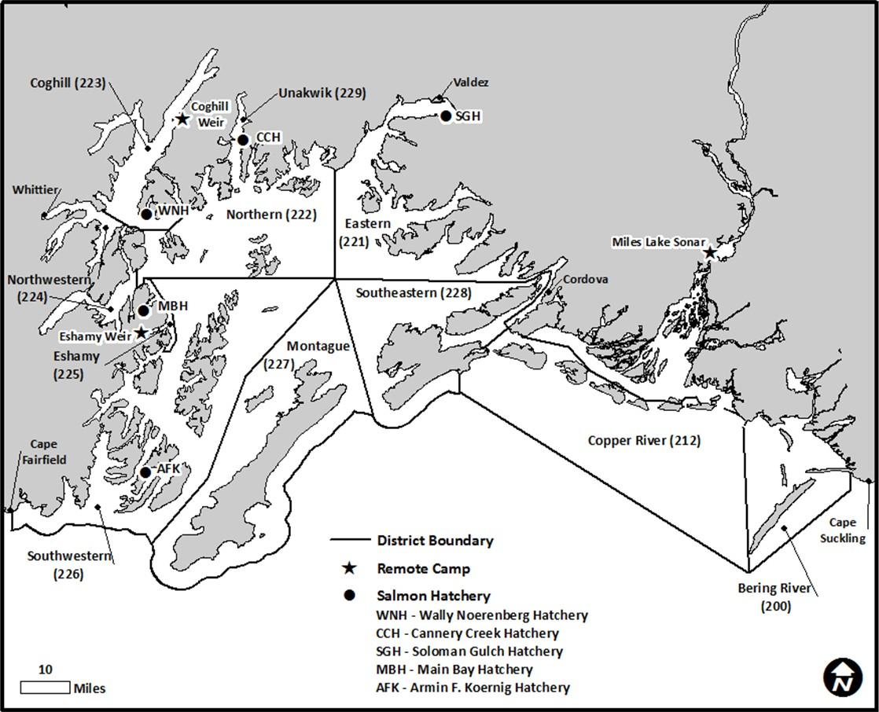

Figure 1.–Prince William Sound Management Area showing commercial fishing districts, salmon hatcheries, weir locations, and Miles Lake sonar camp.

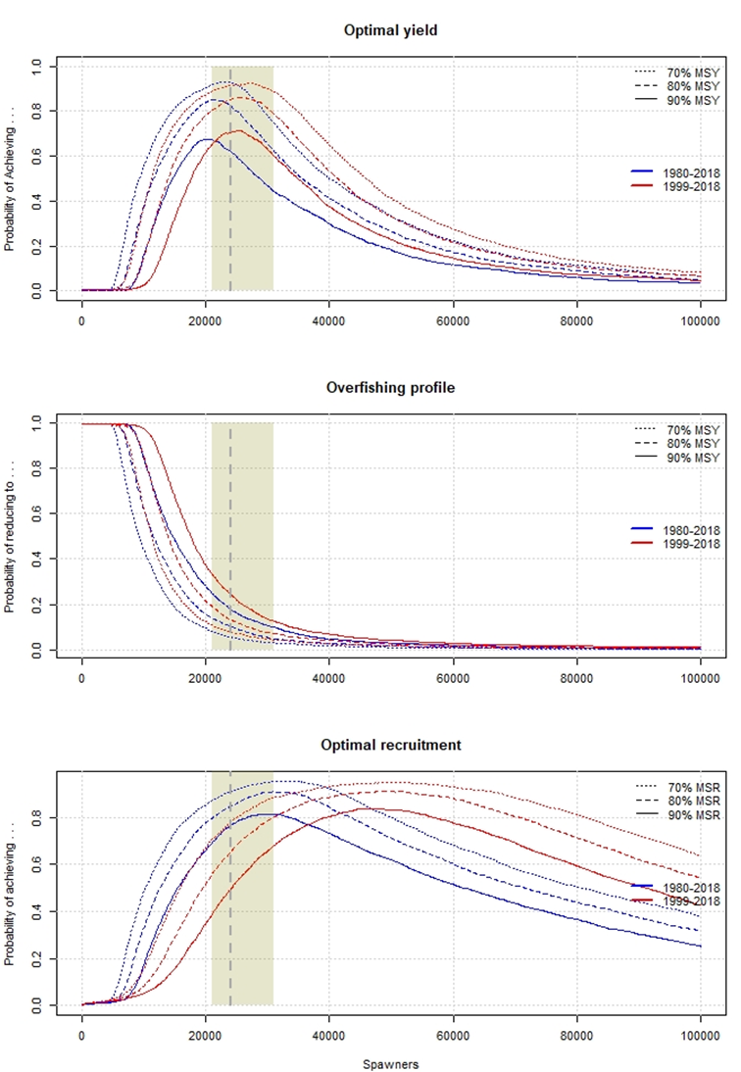

Figure 2.– Optimal yield profiles (OYPs), overfishing profiles (OFPs), and optimal recruitment profiles (ORPs) for Copper RiverChinook salmon as derived from an age-structured state-space model fitted to abundance, harvest, and age data for 1980–2018 (blue) and 1999–2018 (red).

*Note*: OYPs and ORPs show probability that a specified spawning abundance will result in specified fractions (70%, 80%, and 90% line) of maximum sustained yield or maximum recruitment. OFPs show probability that reducing escapement to a specified spawning abundance will result in less than specified fractions of maximum sustained yield. Shaded areas bracket the recommended goal ranges; grey and black marks along the *x*-axis show comparable lower and upper bounds for other Alaskan Chinook salmon stocks scaled by *SMSY* ratios (see Savereide et al. *unpublished*).

32

33

34

35

36

37

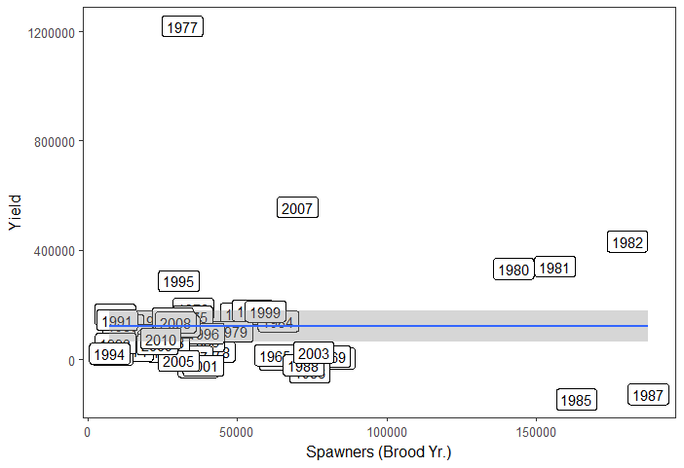

Figure 3.–Coghill Lake sockeye salmon yield (return minus spawners; y-axis) vs. brood-year spawning escapement (Spawners; x-axis).

*Note*: Data include sockeye salmon brood years 1962–2014. The best fit line from a generalized additive model (GAM) is shown in blue with 95% confidence interval in grey. The lack of inflection in the line indicates that yield is relatively constant across the entire range of spawners.

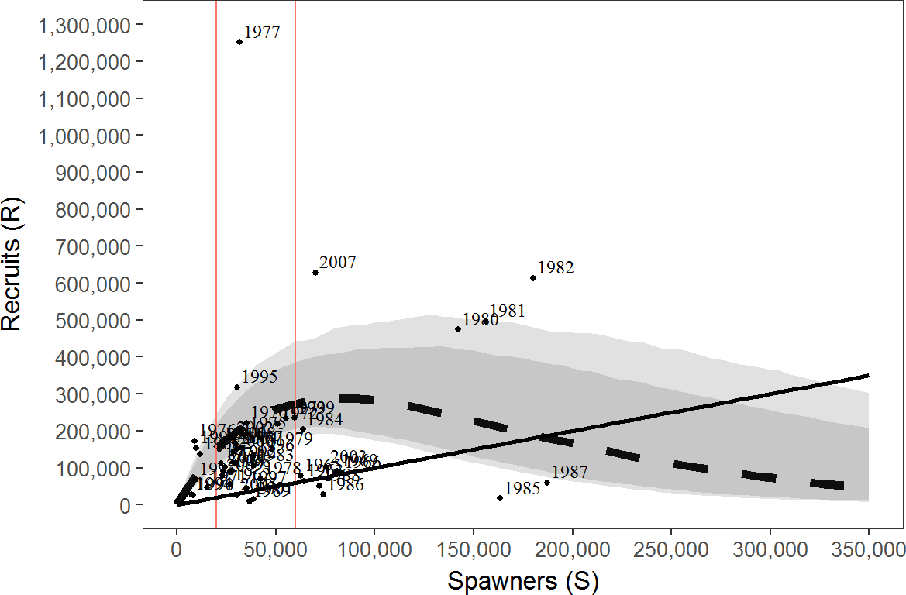

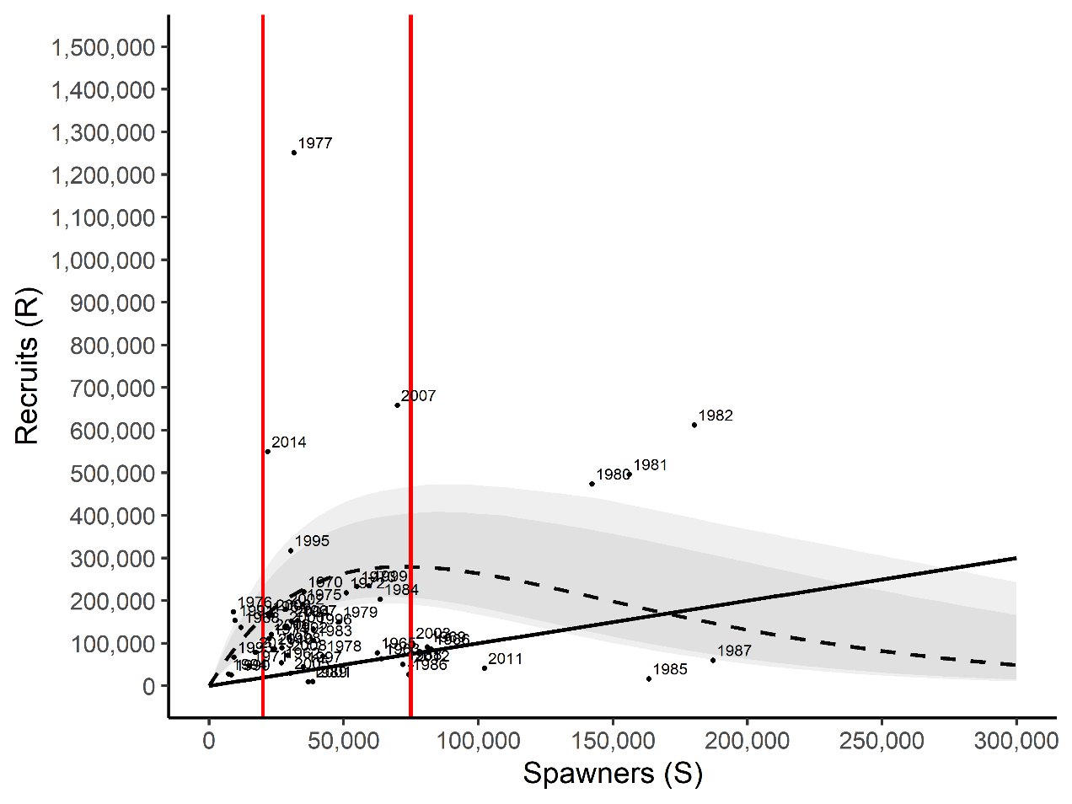

Figure 4.–Plausible spawner-recruit relationships for Coghill Lake sockeye salmon as derived from a Bayesian stock-recruit analysis for brood years 1962–2014.

*Note*: Posterior medians of *R* and *S* are plotted as brood year labels. The heavy dashed line is the Ricker relationship constructed from ln(*α*) and *β* posterior medians with 90% and 95% credibility intervals (shaded areas). Recruits equal spawners on the solid diagonal “replacement” line. The 2 vertical lines show the current SEG range of 20,000–75,000 spawners.

# APPENDIX A: SUPPORTING INFORMATION FOR ESCAPEMENT GOALS FOR SALMON STOCKS IN THE COPPER RIVER, BERING RIVER, AND PRINCE WILLIAM SOUND AREAS

Appendix A1.–Supporting information for analysis of escapement goal for Copper River Chinook salmon.

|  |  |  |
| --- | --- | --- |
| System: Copper River | | |
| Species: Chinook salmon | | |
| Data available for analysis of escapement goals. | | |
| Brood | Measured | Total |
| year | a  escapement | run |
| 1999 | 16,157 | 95,951 |
| 2000 | 24,492 | 70,754 |
| 2001 | 28,208 | 81,155 |
| 2002 | 21,502 | 72,974 |
| 2003 | 34,034 | 94,505 |
| 2004 | 30,645 | 80,559 |
| 2005 | 21,528 | 66,357 |
| 2006 | 58,454 | 99,877 |
| 2007 | 34,575 | 87,770 |
| 2008 | 32,485 | 53,880 |
| 2009 | 27,781 | 43,001 |
| 2010 | 16,771 | 33,181 |
| 2011 | 27,993 | 53,890 |
| 2012 | 27,911 | 44,312 |
| 2013 | 28,727 | 42,645 |
| 2014 | 20,840 | 35,453 |
| 2015 | 26,607 | 56,174 |
| 2016 | 12,534 | 29,243 |
| 2017 | 33,655 | 56,131 |
| 2018 | 42,912 | 61,623 |

*Note*: Current goal is a lower-bound sustainable escapement goal (SEG) of >24,000 Chinook salmon and a change to a range of 18,500–33,000 is recommended.

a Estimated by mark–recapture minus upriver harvests.

43

Appendix A2.–Supporting information for analysis of escapement goal for Bering River District coho salmon.

|  |  |  |
| --- | --- | --- |
| District: Bering River | | |
| Species: coho salmon | | |
| Data available for analysis of escapement goals. | | |
| Return | Wild | Commercial |
| year | escapement a | harvest b,c |
| 1982 | 18,500 | 144,752 |
| 1983 | 11,900 | 117,669 |
| 1984 | 13,000 | 214,632 |
| 1985 | 66,500 | 419,276 |
| 1986 | 7,620 | 115,809 |
| 1987 | 3,985 | 15,864 |
| 1988 | 10,855 | 86,539 |
| 1989 | 14,600 | 26,952 |
| 1990 | 21,840 | 42,952 |
| 1991 | 27,300 | 110,951 |
| 1992 | 13,540 | 125,616 |
| 1993 | 25,650 | 115,833 |
| 1994 | 24,050 | 259,003 |
| 1995 | 22,950 | 282,045 |
| 1996 | 20,000 | 93,763 |
| 1997 | 34,400 | 97 |
| 1998 | 24,700 | 12,284 |
| 1999 | 28,290 | 9,954 |
| 2000 | 23,580 | 56,329 |
| 2001 | 27,107 | 2,715 |
| 2002 | 29,200 | 108,522 |
| 2003 | 22,475 | 59,481 |
| 2004 | 23,685 | 95,595 |
| 2005 | 32,442 | 43,030 |
| 2006 | 24,292 | 56,723 |
| 2007 | 27,452 | 9,305 |
| 2008 | 28,932 | 40,380 |
| 2009 | 22,141 | 45,542 |
| 2010 | 21,311 | 80,642 |
| 2011 | 18,890 | 19,966 |
| 2012 | 15,605 | 46,324 |
| 2013 | 18,020 | 46,959 |
| 2014 | 26,475 | 97,679 |
| 2015 | 15,550 | 12,116 |
| 2016 | 26,150 | 80,094 |
| 2017 | 30,650 | 119,090 |
| 2018 | 26,626 | 120,774 |

a Escapement indices calculated as peak aerial survey from the 7 primary index systems.

b The Kayak Island Subdistrict closed to commercial fishing in 1986.

c Harvest in the Bering River District, not stock specific.

-continued-

Appendix A2.–Page 2 of 2.

|  |
| --- |
| District: Bering River |
| Species: coho salmon |
| Observed escapement by year (blocked line) and current SEG range (solid line). |

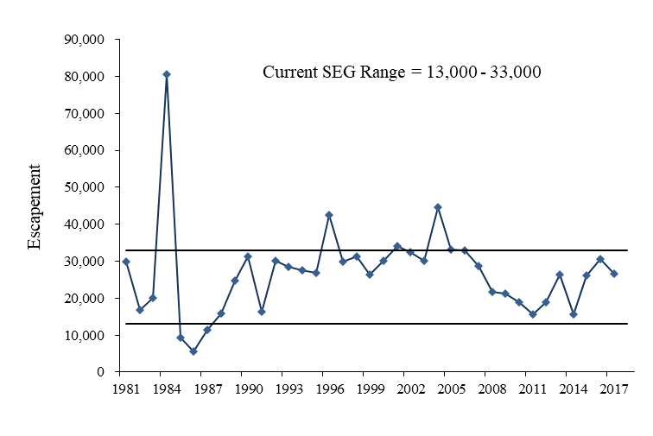

49

Appendix A3.–Supporting information for analysis of escapement goal for Copper River Delta coho salmon.

|  |  |  |  |  |
| --- | --- | --- | --- | --- |
| District: Copper River Delta | |  |  |  |
| Species: coho salmon | |  |  |  |
| Data available for analysis of escapement goals. | | | |  |
| Return | Wild |  | Harvest |  |
| Year | Escapement a |  | Commercial b | Sport c |
| 1981 | 44,800 |  | 310,154 | 0 |
| 1982 | 40,575 |  | 454,763 | 398 |
| 1983 | 60,050 |  | 234,243 | 84 |
| 1984 | 64,525 |  | 382,432 | 1,780 |
| 1985 | 106,410 |  | 587,990 | 649 |
| 1986 | 25,790 |  | 295,980 | 2,969 |
| 1987 | 26,465 |  | 111,599 | 1,010 |
| 1988 | 26,560 |  | 315,568 | 1,492 |
| 1989 | 40,856 |  | 194,454 | 2,118 |
| 1990 | 41,281 |  | 246,797 | 1,778 |
| 1991 | 63,656 |  | 385,086 | 1,941 |
| 1992 | 44,013 |  | 291,627 | 3,854 |
| 1993 | 31,870 |  | 281,469 | 4,139 |
| 1994 | 43,955 |  | 677,633 | 4,293 |
| 1995 | 34,480 |  | 542,658 | 2,543 |
| 1996 | 46,110 |  | 193,042 | 6,364 |
| 1997 | 55,360 |  | 18,656 | 2,825 |
| 1998 | 42,200 |  | 108,232 | 4,230 |
| 1999 | 43,725 |  | 153,061 | 6,978 |
| 2000 | 42,830 |  | 304,944 | 4,479 |
| 2001 | 40,496 |  | 251,473 | 12,144 |
| 2002 | 87,415 |  | 504,223 | 6,909 |
| 2003 | 72,055 |  | 363,489 | 14,443 |
| 2004 | 99,505 |  | 467,859 | 14,643 |
| 2005 | 99,682 |  | 263,465 | 9,799 |
| 2006 | 89,070 |  | 318,285 | 5,531 |
| 2007 | 51,215 |  | 117,182 | 6,749 |
| 2008 | 74,772 |  | 202,621 | 7,763 |
| 2009 | 40,124 |  | 207,776 | 14,420 |
| 2010 | 40,377 |  | 210,621 | 15,866 |
| 2011 | 38,145 |  | 127,511 | 14,304 |
| 2012 | 36,735 |  | 130,261 | 15,230 |
| 2013 | 34,630 |  | 244,985 | 17,053 |
| 2014 | 44,040 |  | 315,776 | 16,226 |
| 2015 | 42,065 |  | 136,981 | 24,515 |
| 2016 | 76,200 |  | 367,630 | 13,094 |
| 2017 | 43,760 |  | 306,287 | 9,582 |
| 2018 | 53,800 |  | 303,957 | 12,117 |

a Escapement indices calculated as peak aerial survey from the 18 primary index systems.

b Copper River District harvest, not stock specific.

c From statewide harvest survey. The sport harvest includes both upriver and Copper River Delta harvests.

-continued-

Appendix A3.**–**Page 2 of 2.

|  |
| --- |
| District: Copper River Delta |
| Species: coho salmon |
| Observed escapement by year (blocked line) and current SEG range (solid line). |

Appendix A4.–Supporting information for analysis of escapement goal for Bering River District sockeye salmon.

|  |  |  |
| --- | --- | --- |
| System: | Bering River District | |
| Species: | sockeye salmon | |
| Data available for analysis of escapement goals. | | |
|  |  |  |
| Brood | Wild | Commercial |
| Year | Escapement a | Harvest b |
| 1988 | 13,680 | 7,152 |
| 1989 | 23,300 | 9,225 |
| 1990 | 19,741 | 8,332 |
| 1991 | 32,220 | 19,181 |
| 1992 | 55,895 | 19,721 |
| 1993 | 27,725 | 33,951 |
| 1994 | 26,550 | 27,926 |
| 1995 | 33,450 | 21,585 |
| 1996 | 27,310 | 37,712 |
| 1997 | 15,065 | 9,651 |
| 1998 | 23,450 | 8,439 |
| 1999 | 46,195 | 13,697 |
| 2000 | 24,220 | 1,279 |
| 2001 | 8,823 | 5,450 |
| 2002 | 24,715 | 235 |
| 2003 | 49,840 | 18,266 |
| 2004 | 25,135 | 13,165 |
| 2005 | 30,890 | 77,465 |
| 2006 | 14,671 | 36,867 |
| 2007 | 21,170 | 16,470 |
| 2008 | 18,196 | 1,175 |
| 2009 | 13,471 | 4,157 |
| 2010 | 4,367 | 51 |
| 2011 | 28,530 | 6 |
| 2012 | 18,290 | 0 |
| 2013 | 23,900 | 3,321 |
| 2014 | 14,885 | 50 |
| 2015 | 22,705 | 2,137 |
| 2016 | 16,390 | 9,840 |
| 2017 | 19,115 | 2,578 |
| 2018 | 13,300 | 33 |

a Escapement indices calculated as the sum of peak aerial index counts from 6 primary index systems

b Bering River District harvest, not stock specific.

-continued-

Appendix A4.**–**Page 2 of 2.

|  |  |
| --- | --- |
| System: | Bering River |
| Species: | sockeye salmon |
| Observed escapement by year (blocked line) and current SEG range (solid line). | |

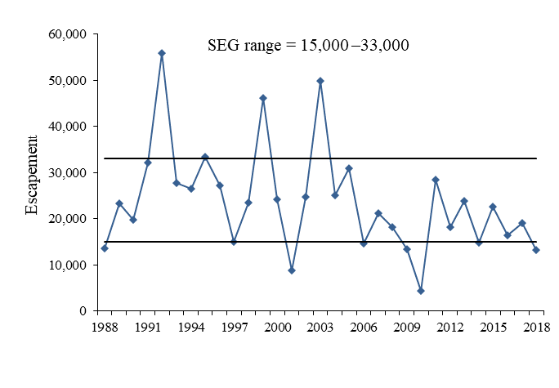

Appendix A11.–Links to repositories of code used in analysis of escapement goals for Prince William Sound pink and chum salmon, and Coghill Lake sockeye salmon.

<https://github.com/commfish/PWS_Pink_Chum_EG>

<https://github.com/commfish/Coghill_sockeye>